Mass spectrometry

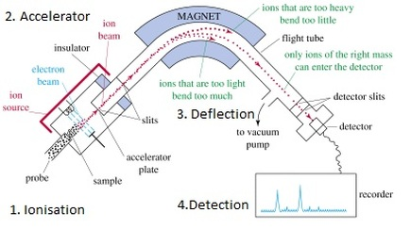

1. **What is Mass spectrometry?**

Mass spectrometry is an analytical chemistry technique that helps identify the amount and type of chemicals present in a sample by measuring the mass-to-charge ratio and abundance of gas-phase ions.

A mass spectrum is a plot of the ion signal as a function of the mass-to-charge ratio. The spectra are used to determine the elemental or isotopic signature of a sample, the masses of particles and of molecules, and to elucidate the chemical structures of molecules, such as peptides and other chemical compounds. Mass spectrometry works by ionizing chemical compounds to generate charged molecules or molecule fragments and measuring their mass-to-charge ratios.

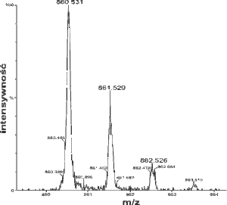

1. **The Discovery of Mass Spectrometry**

According to reliable online resources, W. Wein used electric and magnetic fields to make the positive ion beam deflected, in the same time he realized that when the charge is the dame, the ions with small mass is deflected more than the ions with large mass. In 1919 Aston created a Mass spectrometer which can resolute to the hundredth unit of mass to measure the relative abundance of isotopes and identified a number of isotopes.

1. **The Physic Principle of Mass Spectrometry**

Mass analyzers separate the ions according to their mass-to-charge ratio. The following two laws govern the dynamics of charged particles in electric and magnetic fields in vacuum:

\mathbf{F} = Q (\mathbf{E} + \mathbf{v} \times \mathbf{B})(Lorentz force law)

\mathbf{F}=m\mathbf{a} (Newton's second law of motion in non-relativistic case)

Here F is the force applied to the ion, m is the mass of the ion, a is the acceleration, Q is the ion charge, E is the electric field, and v × B is the vector cross product of the ion velocity and the magnetic field

Equating the above expressions for the force applied to the ion yields:

(m/Q)\mathbf{a} = \mathbf{E}+ \mathbf{v} \times \mathbf{B}.